Damian Zylski
CMPSC 206
Website project phase 1

This website will be based on Shinra electric power company from Final Fantasy 7. The purpose of this website is to provide information, about Shinra, it's products, it's services, the company departments, and those who run the company.

The goals the website will accomplish are that it will prove it's better than other electric power companies, show how it's products are great, and show how it's leaders are also great.

My target audience would probably fans of Final Fantasy 7 or young adults.

The opportunity my website would try to fulfill is trying to sell products to customers and the topic would be to address the energy and how it is derived.

I can certainly think of some images, and perhaps a video that would likely work to enhance my website.

Two URL's with similar content would be:

https://www.kindermorgan.com/
https://www.giantbomb.com/shinra-electric-power-company/3015-53/
WIRE FRAME AND FLOW CHART ARE BELOW!
Flow Chart and file names
The files shall be Home = index.html, Energy = energy.html, products/orders = products.html, departments = departments.html, about = about.html and project.css. The other file names will be determined at a later time. Added product.html

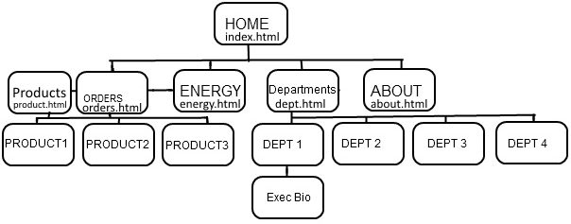

Wire Frame
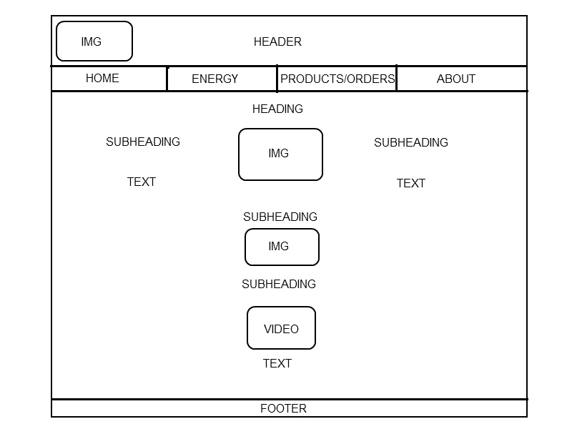

COLORS
For colors I plan to use shades of black, red, white, and some aqua green. Black will be the background, red will makeup borders and tabs maybe some headings, white will be primarily text, and aqua green will be used with some images.

FONTS
The fonts I plan to use for now are Times New Roman, Arial, and maybe some courier new.

OBJECT CONFIGURATIONS
The header will contain heading 1. The first heading will be heading 2. Heading 3 will be the subheadings on the left and right. Background will be black. Company logo will appear in the top left header. Header will display company name in an undecided size and color. Maybe red. One of the subheadings might have an unordered list and paragraphs. Images and headings will be centered and make up the middle column as well as some paragraphs. Nav bar might be red for now. Background will be black. Might use the same font throughout the page which will probably be Times New Roman. Might use a unique font for the company name and the size will be large. Footer area will also be red for now.

